**Tableau Parts 9 and 10: Exercises with answers**

Exercise 9

1. Import the ‘employee.csv’, ‘department.csv’ and ‘project.csv’ into Tableau. Combine all the 3 tables using Relationships by dragging the tables into the canvas.

Answer:

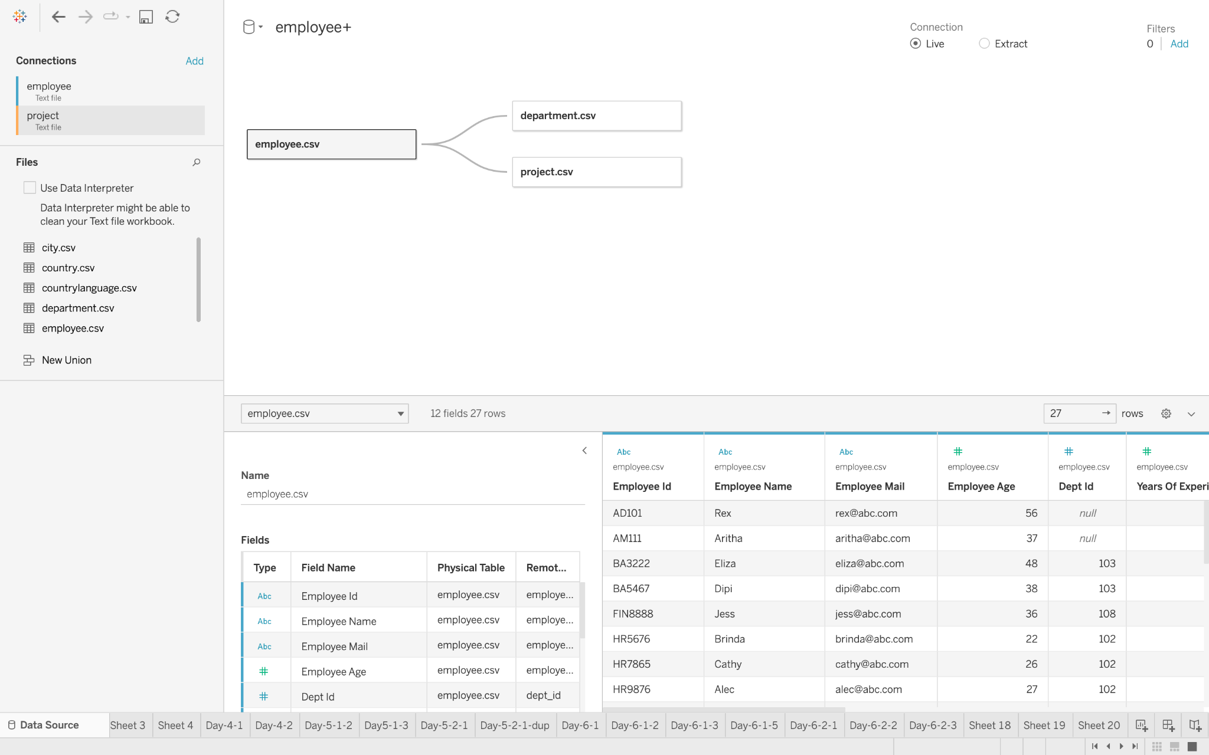

# 

1. Create a table of dept_id, employee_name and SUM(years_of_experience).

Answer:

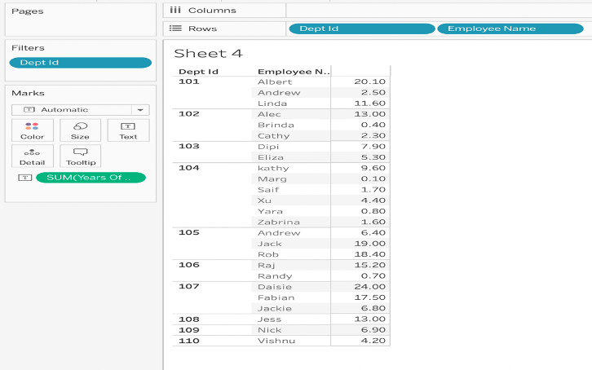

1. Print the first three letters from the name of the employee.

Answer: Use formula ‘MID([employee_name],1,3)’

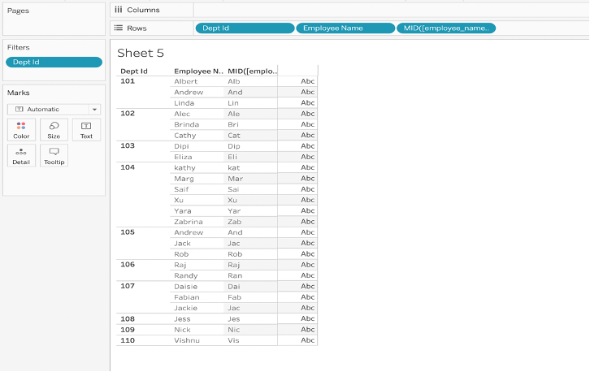

1. Imagine that there has been a mistake during the entry of employee names. Use the formula to replace all mentions of Kathy to Cathy.

Answer: REPLACE([employee_name],"kathy","Cathy")

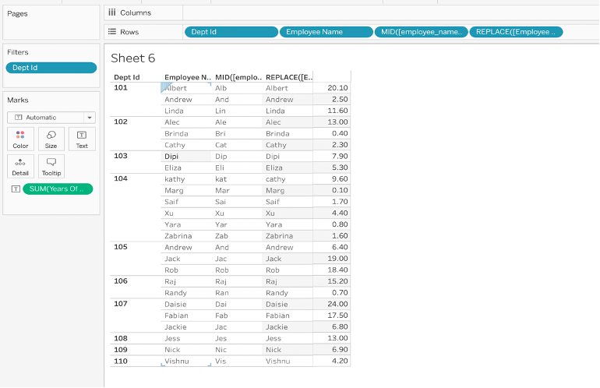

1. Remove all the “@abc.com” in employee email addresses using REPLACE. (Hint: You can replace “@abc.com” with a blank.)

Answer: REPLACE([employee_mail], "@abc.com", "")

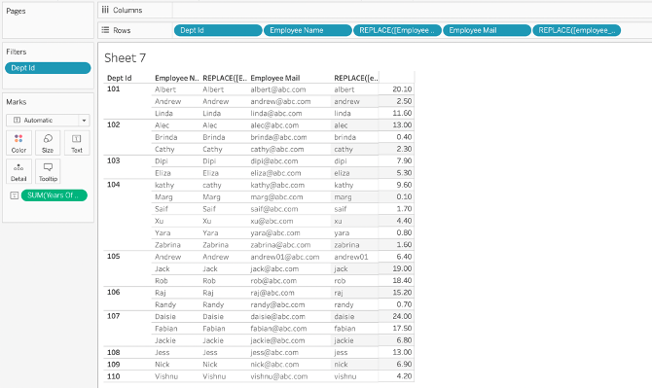

Exercise 10

1. Create a bar chart of the start_date (in Years) in the Rows and AVG(years_of_experience) in the Columns. In addition, use the DATEPART formula to display the month of the start_date.(note-convert calculated to date type)

Answer:

DATEPART('month', [start_date])

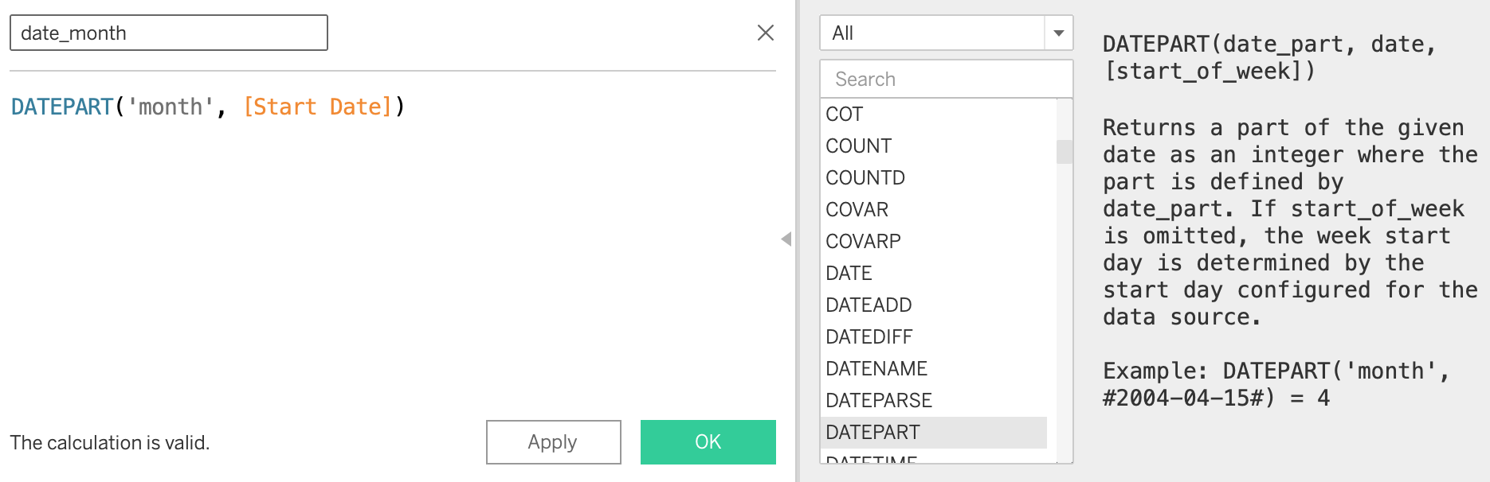

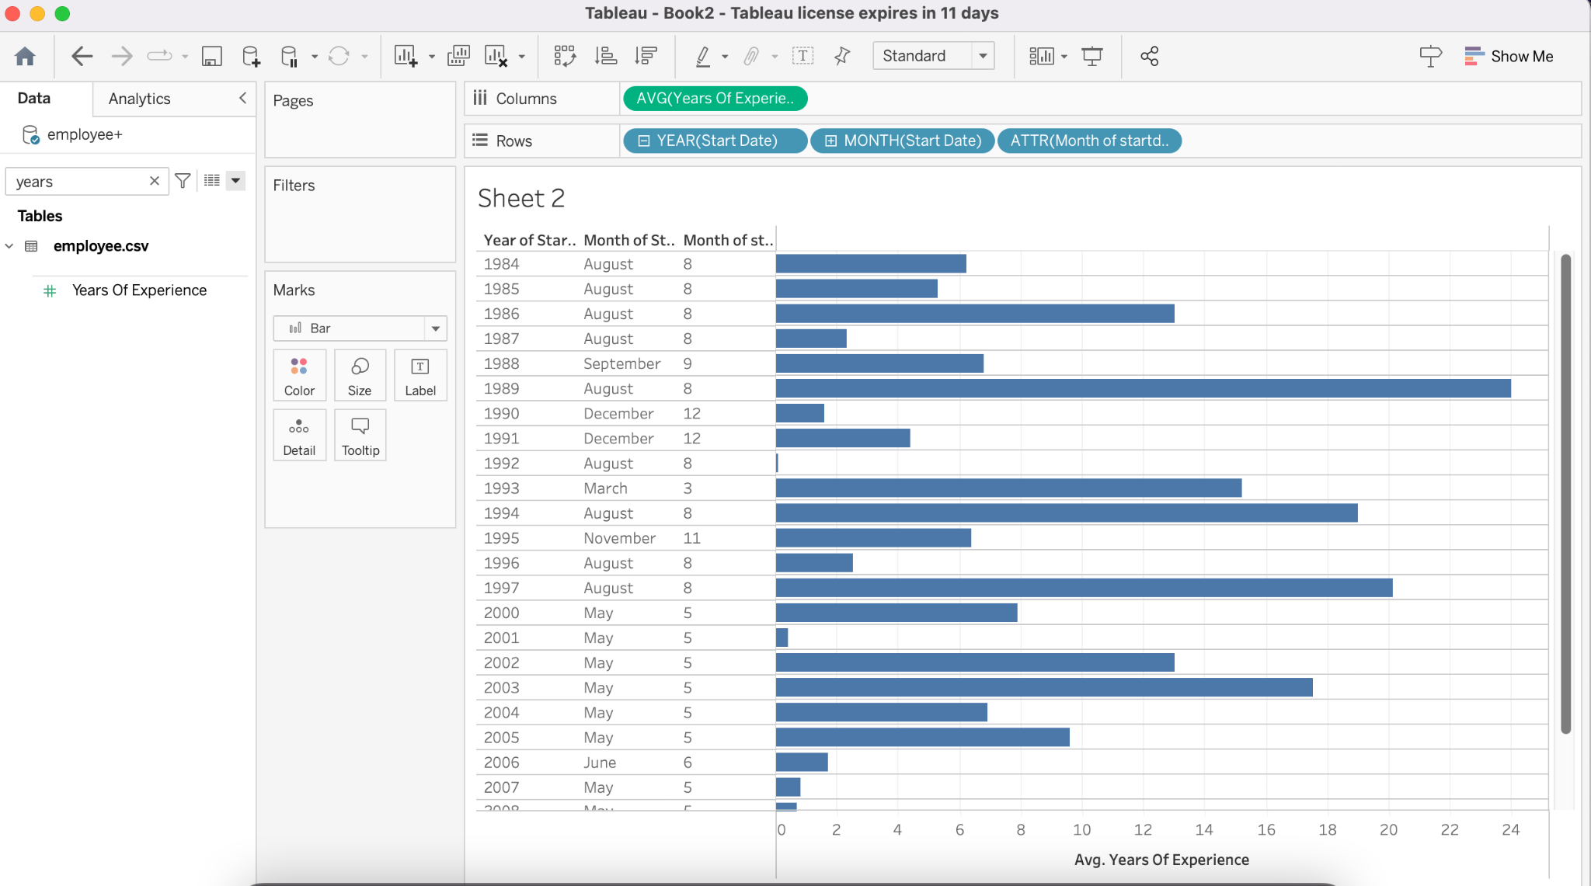

1. Convert the dept_id to STR type.

Answer:

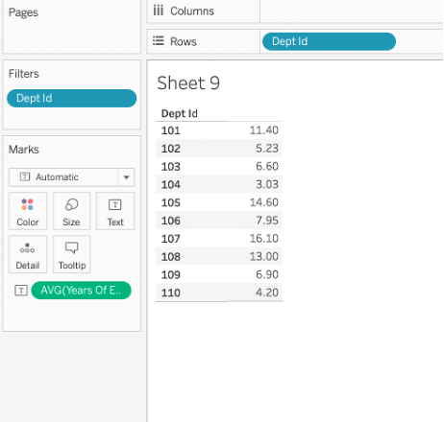

1. Create a new calculated field called “Above30 / Below30” using the average age of the employees. If the average age is greater than 30, designate the department as Above30. Otherwise, it is Below30.

Answer:

